# Introduction to an Amazon Linux Amazon Machine Image (AMI)

## Accessing the AWS Management Console

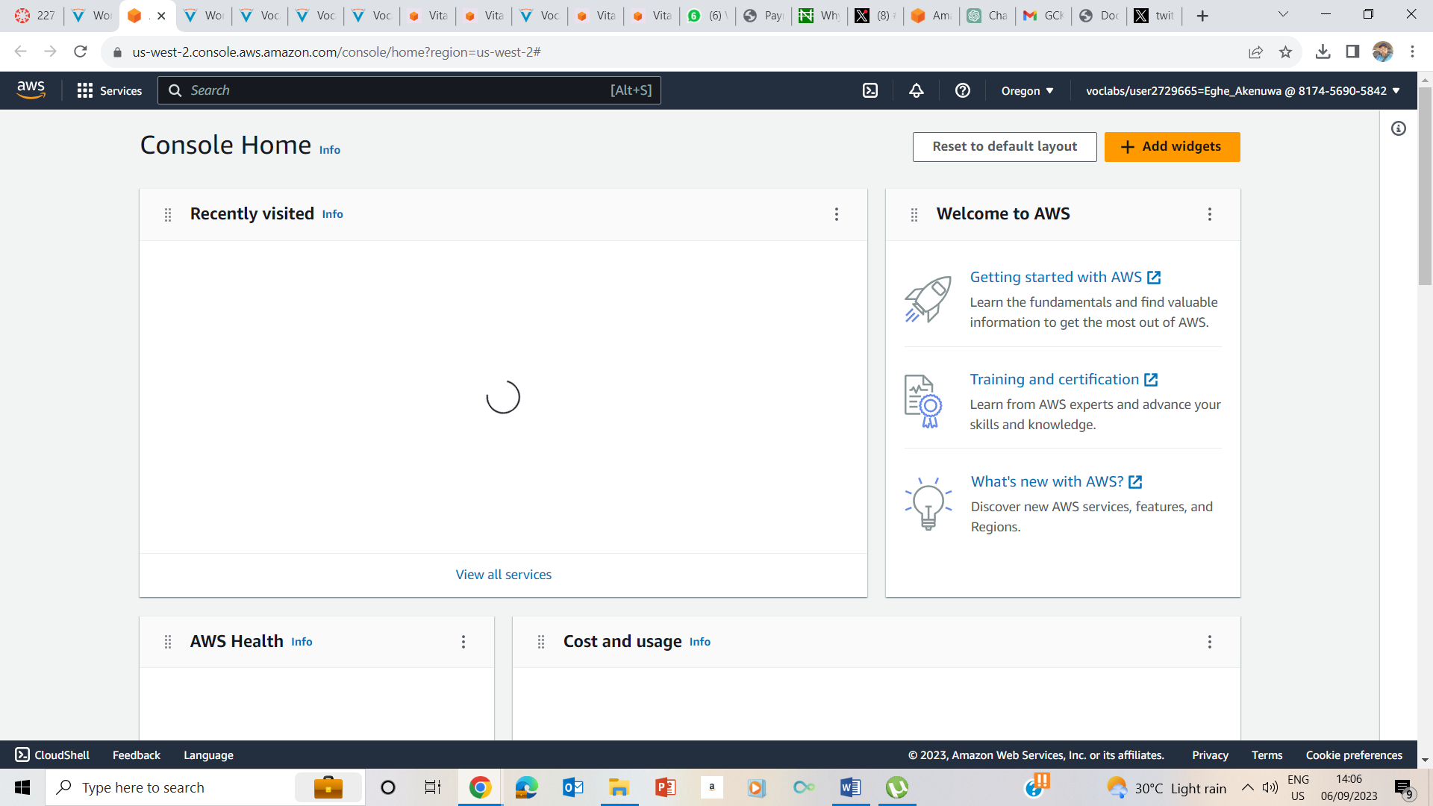

**Task 1: Use SSH to connect to an Amazon Linux EC2 instance**

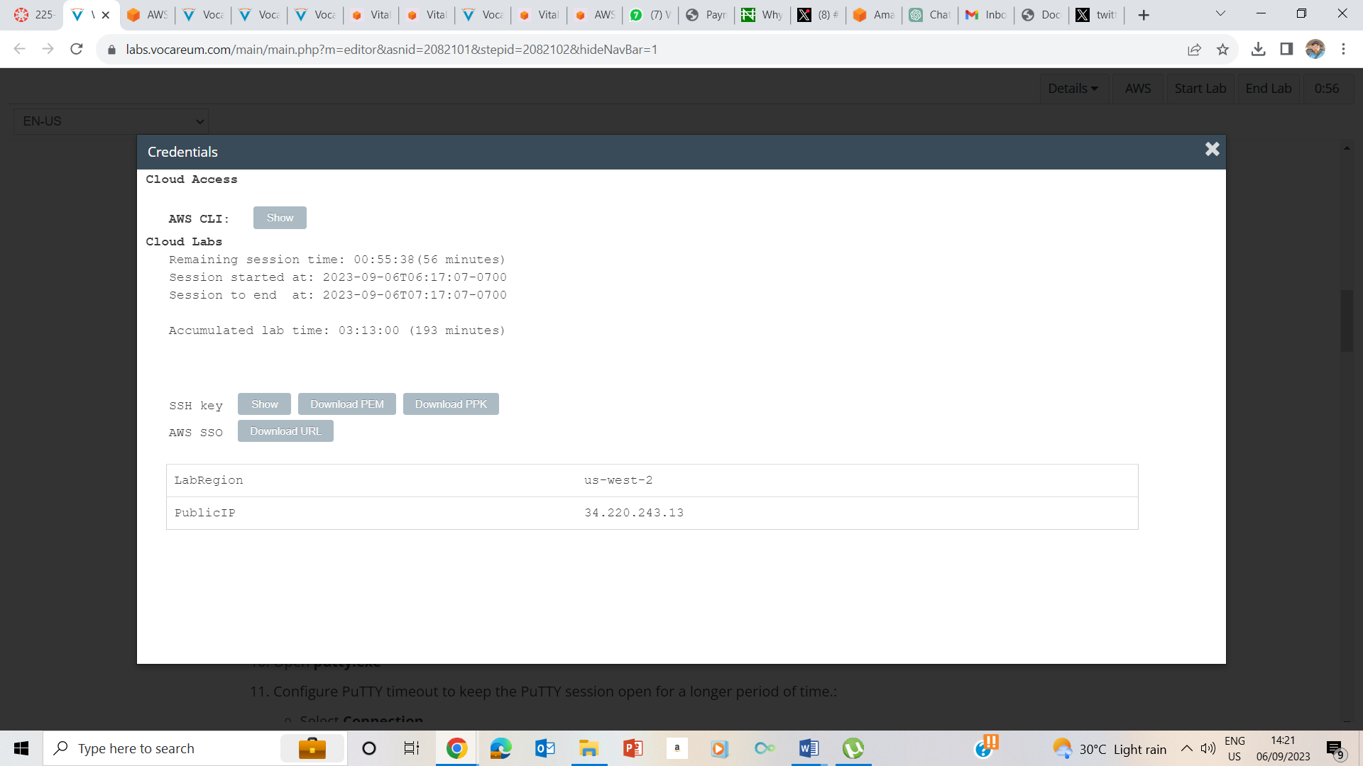

5-7. I clicked on the details drop down box, and selected show to download the PPK file as well as make note of the public IP address

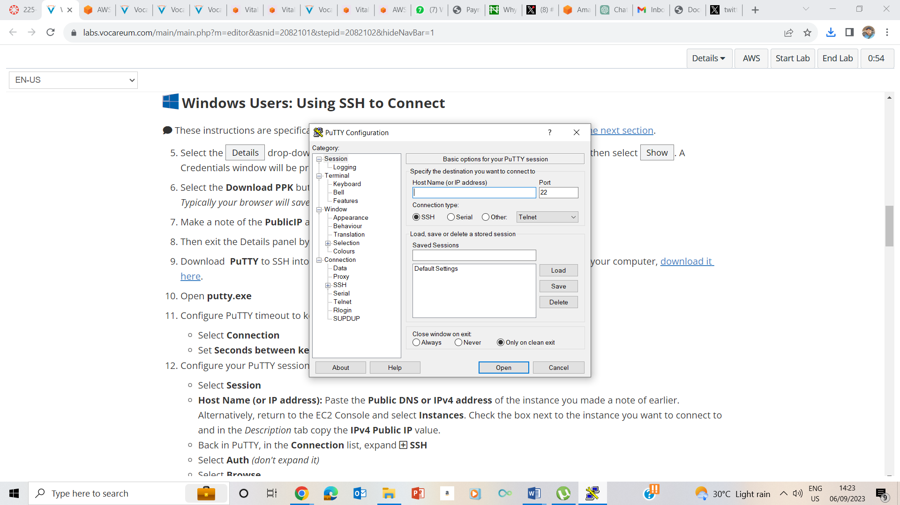

6-8 . I downloaded putty. Ran the putty.exe file and on the connections, I set the seconds before time to be 30.

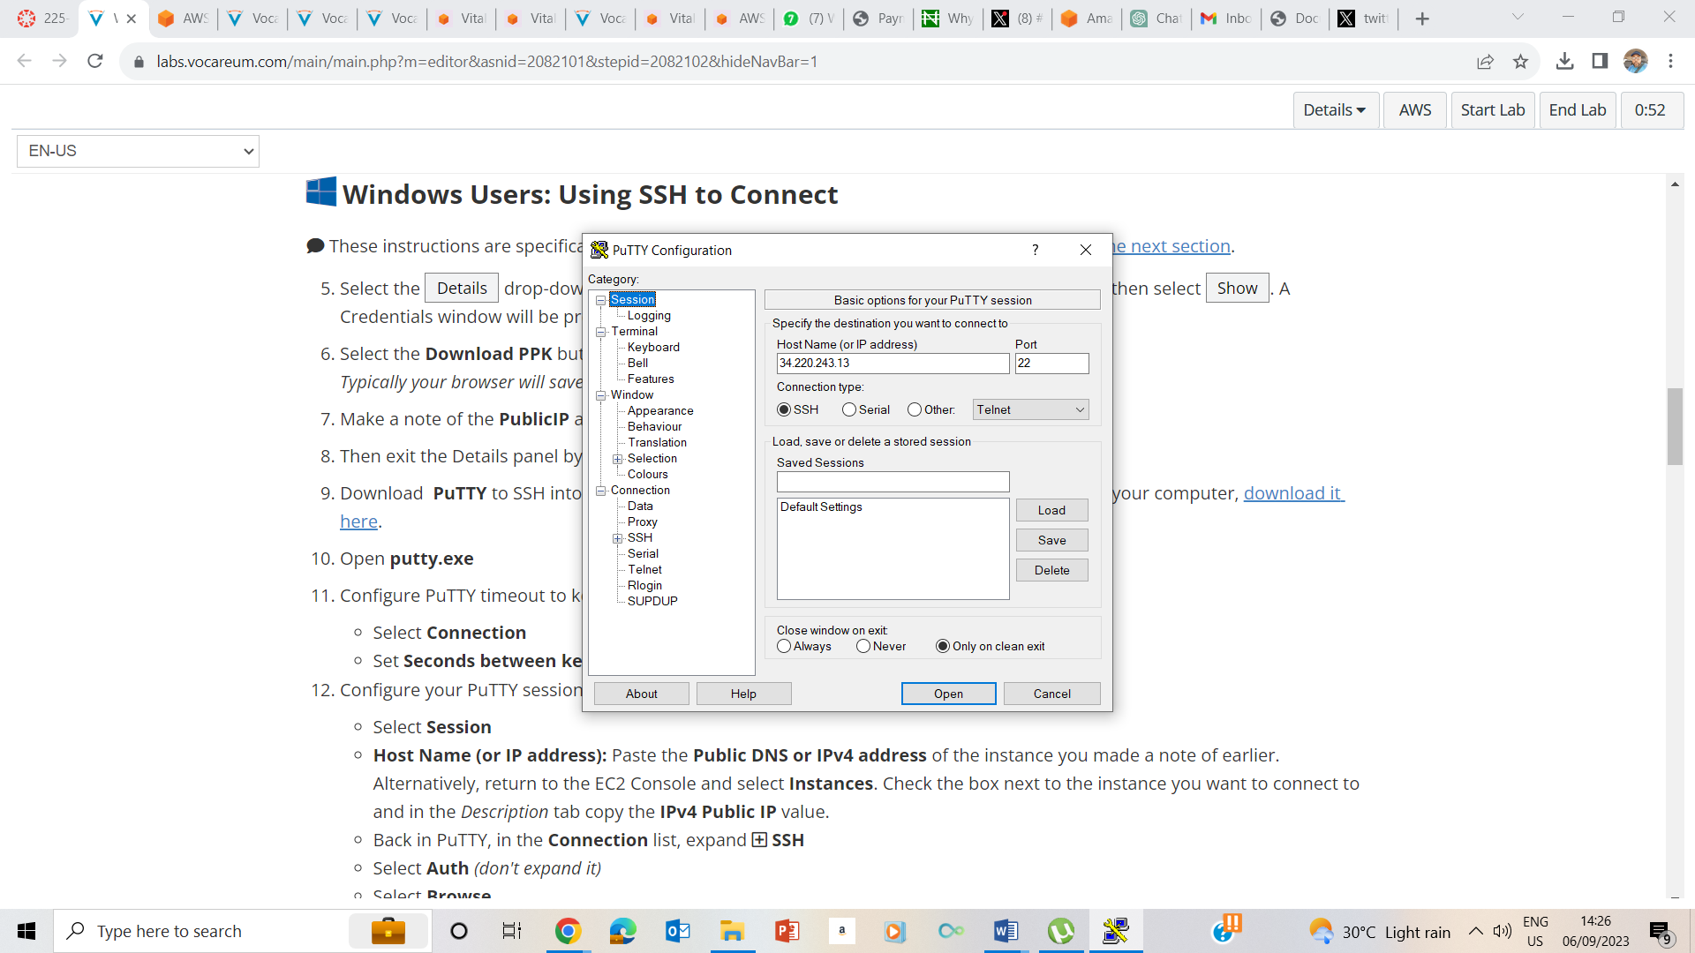

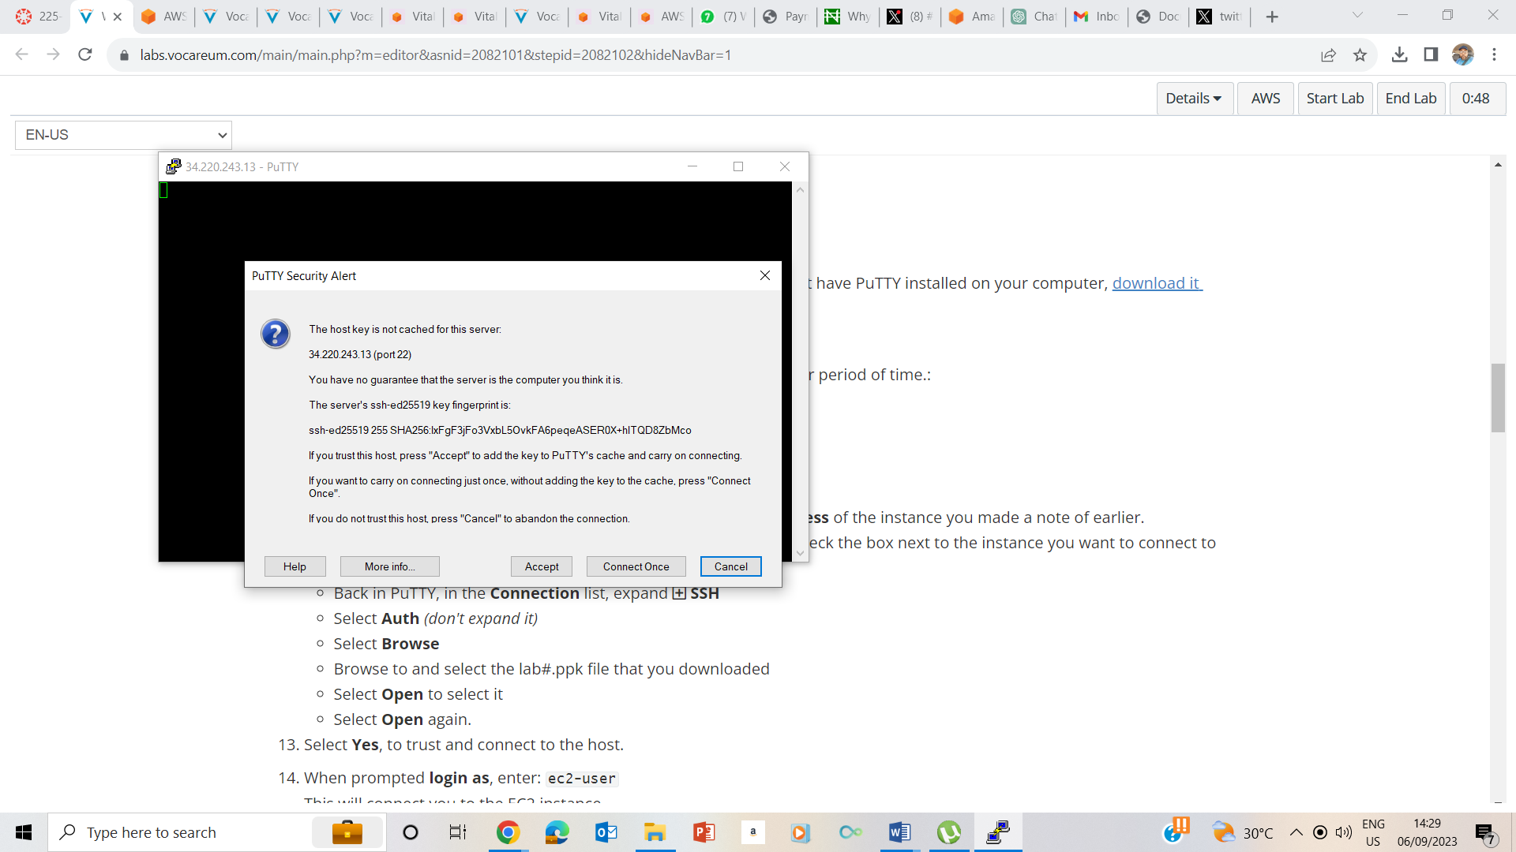

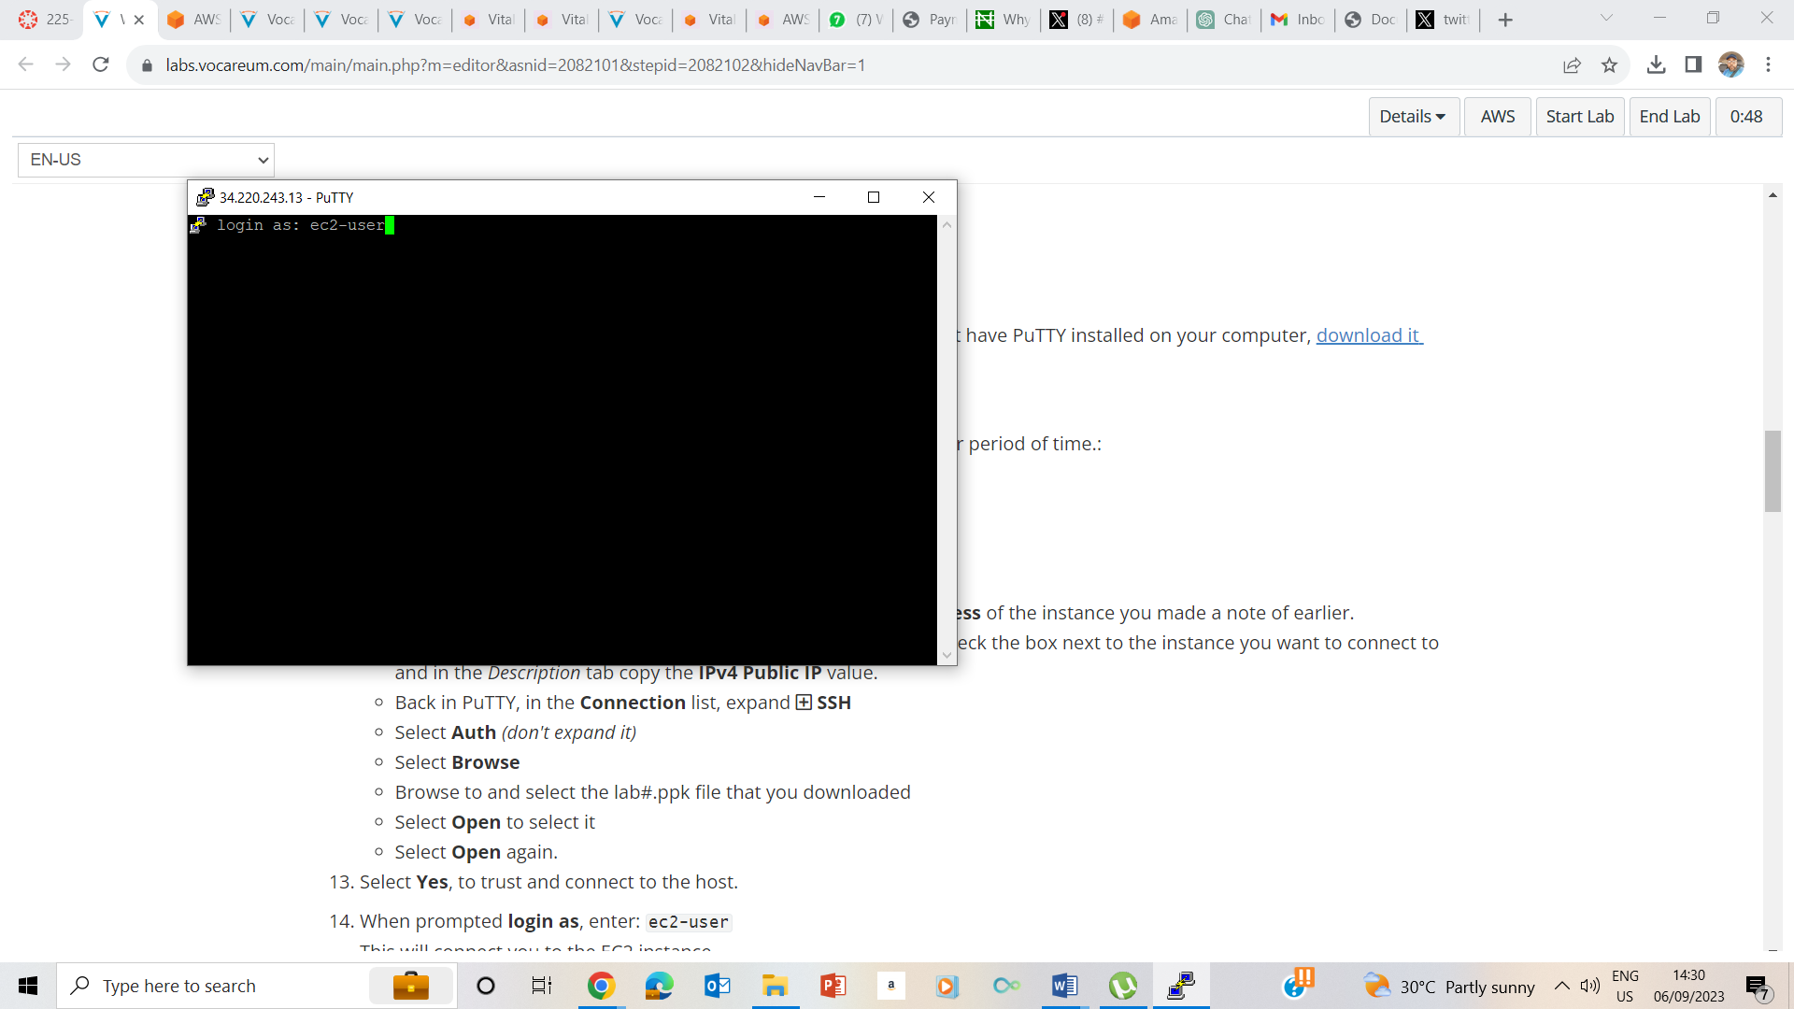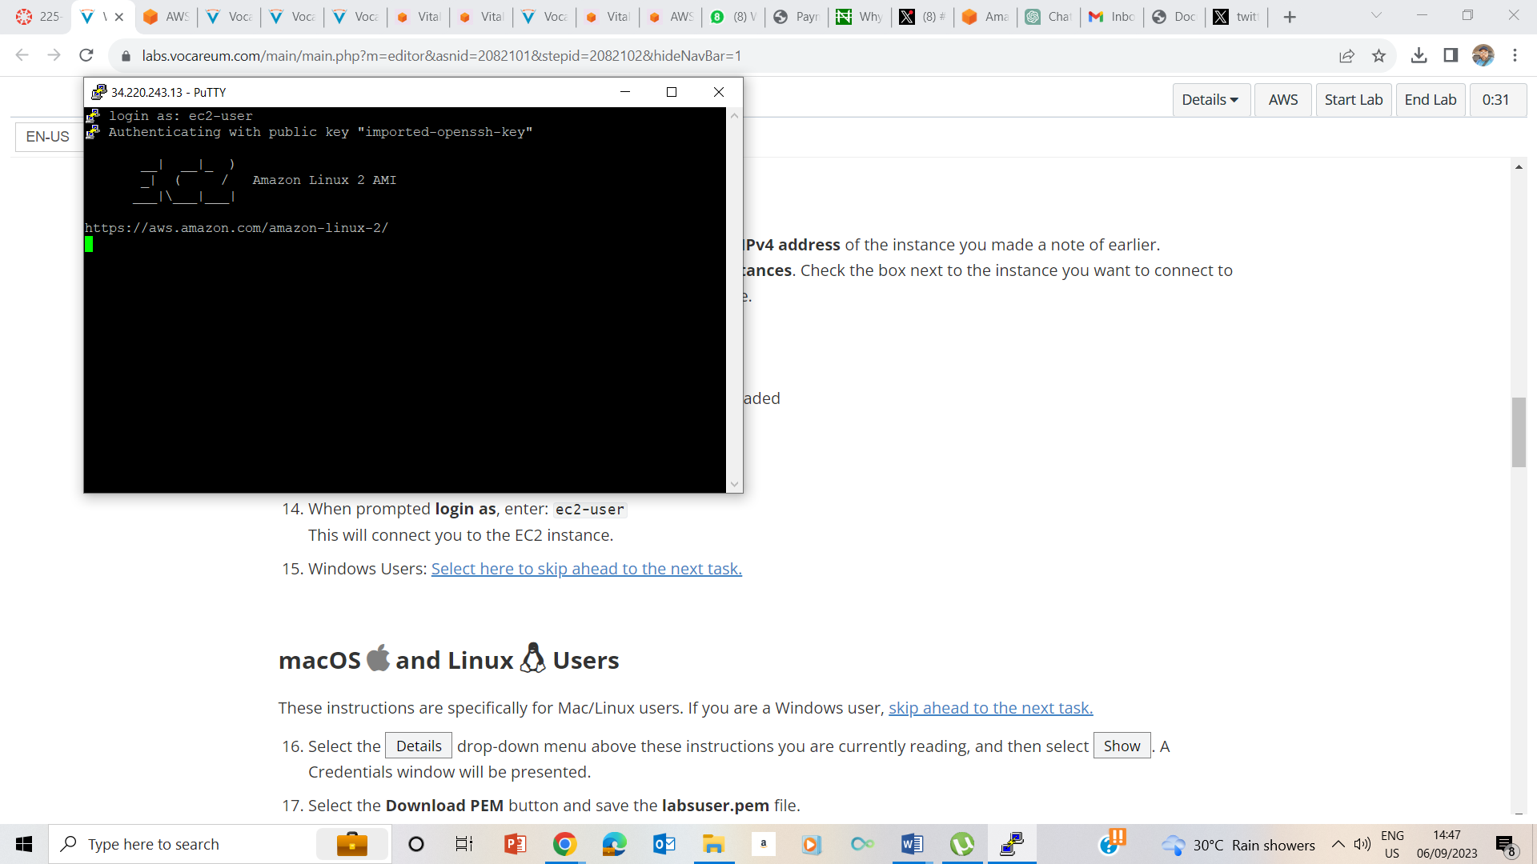

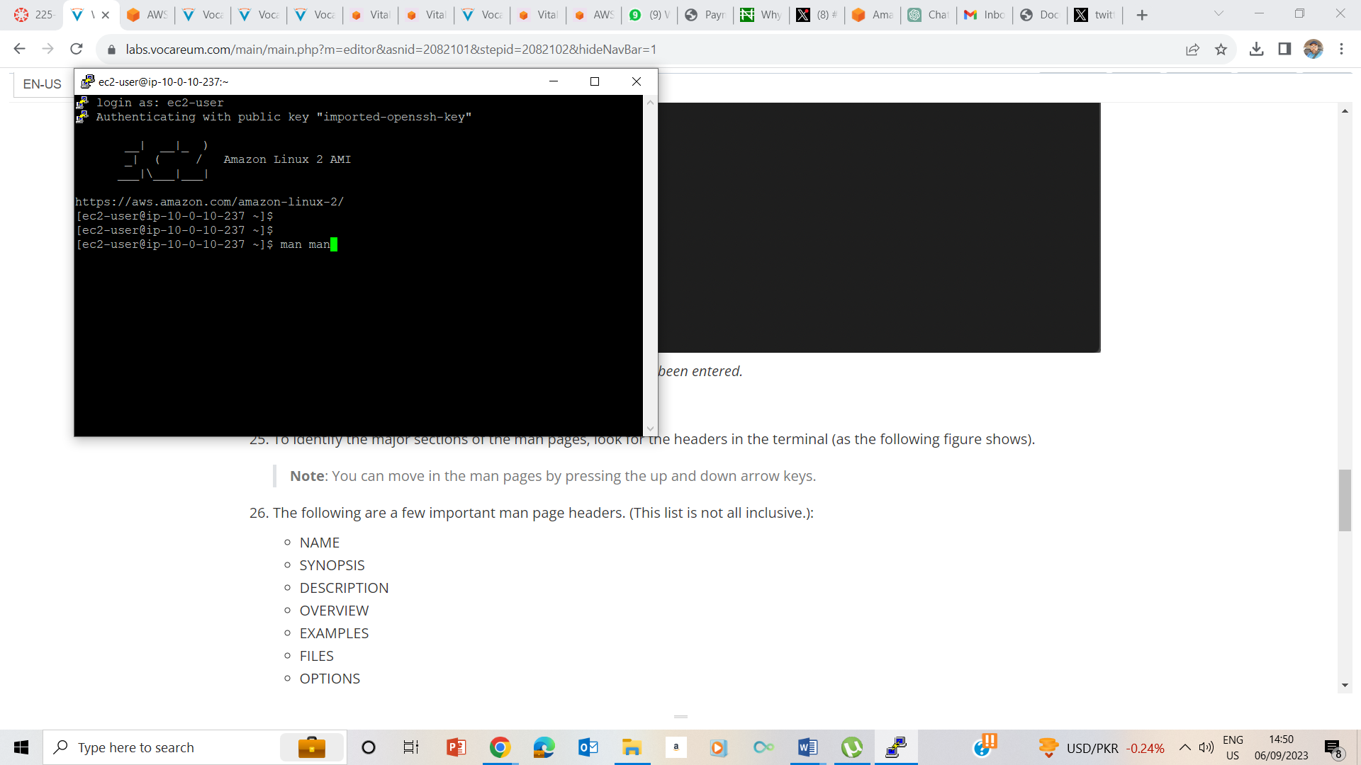

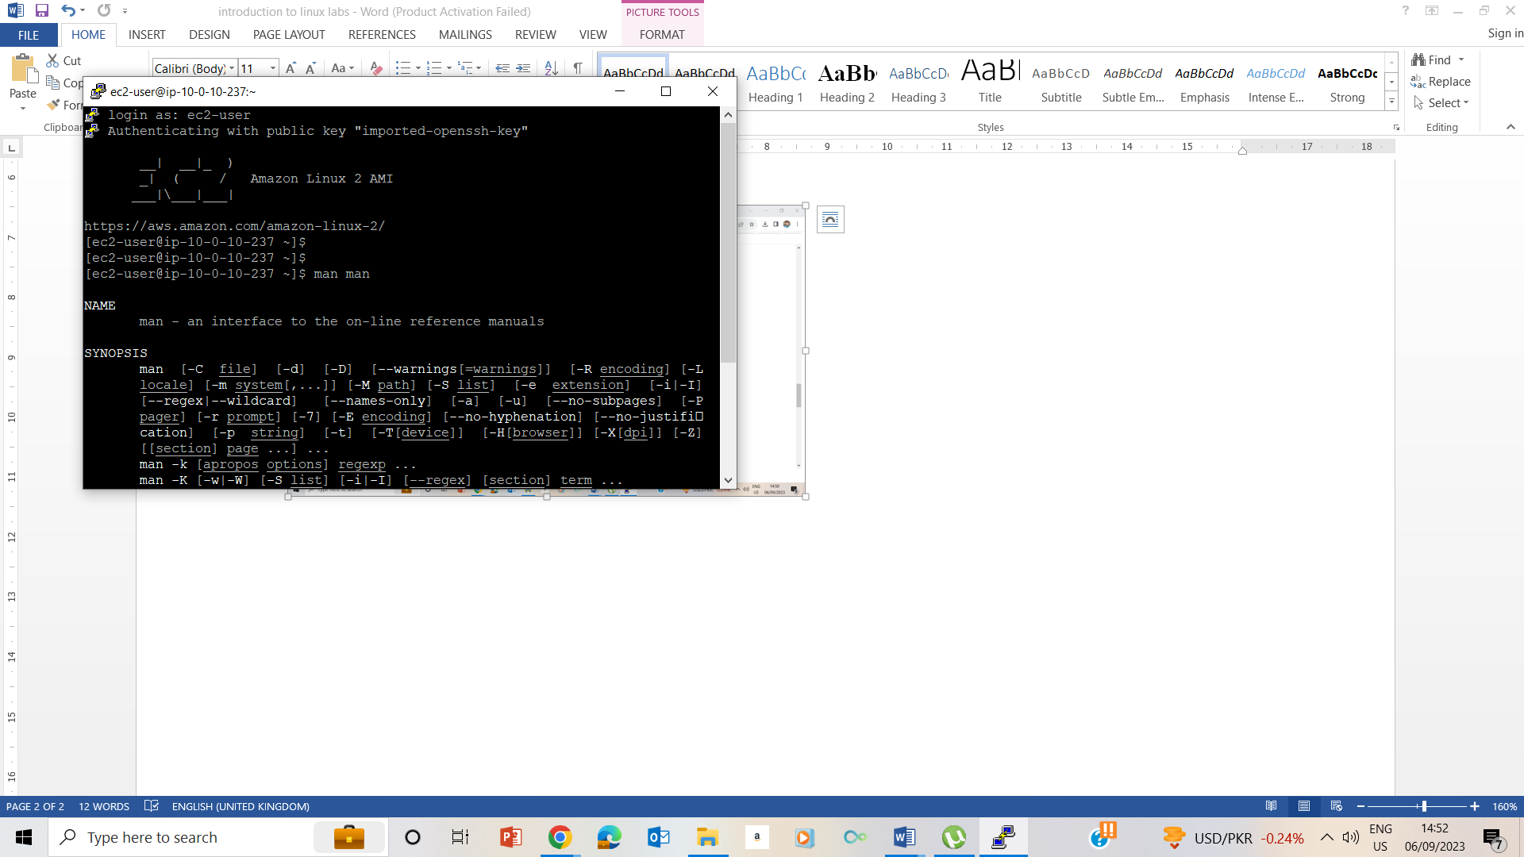

12 - 15. I configured the putty session, by inputting the public ip address as well as inputting the ppk file I had previously downloaded following the instructions given.

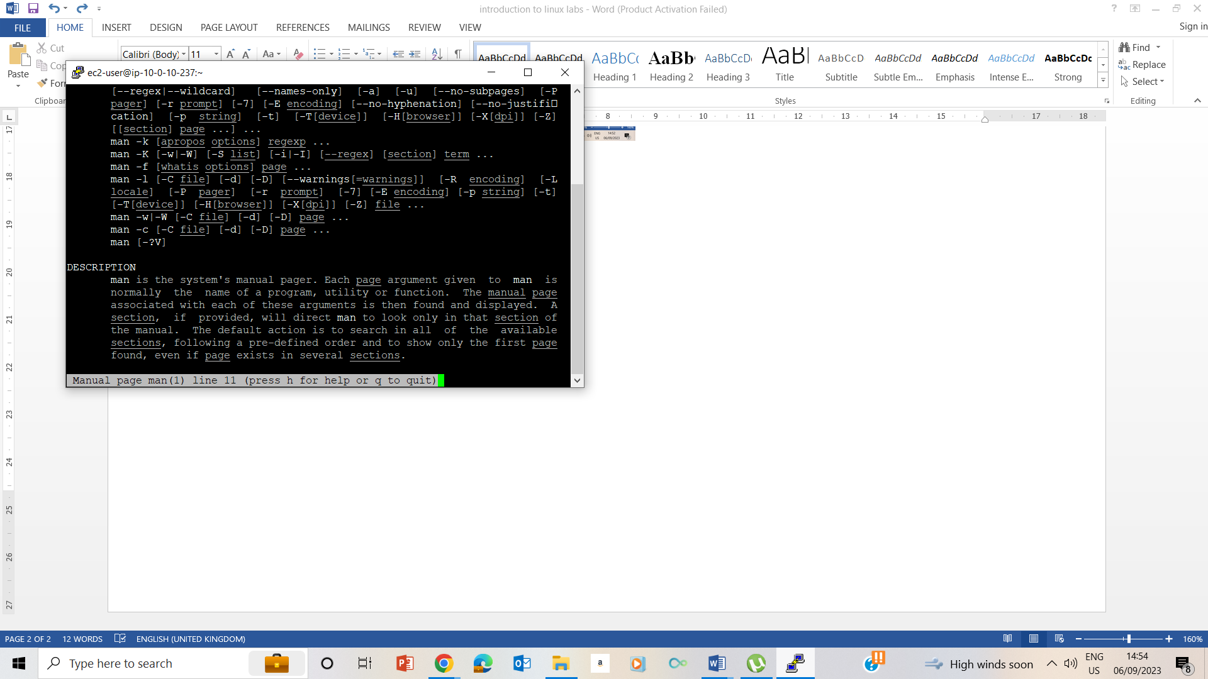

24-27. I used man man command to understand major sections of the man command as well as various important man page headers. I also noted the Description header and what it does

28. I used q to quit and ended the lab.